Multi-Dataset Investigation of Attention- Enhanced CNN for High-Performance Deepfake Detection

A Project Work Stage I & II Dissertation submitted to the
Jawaharlal Nehru Technological University, Hyderabad
in partial fulfillment of the requirement for the award of a degree of

BACHELOR OF TECHNOLOGY IN
CSE(DATA SCIENCE)

Submitted by

M. Manogna 22B81A6785
S. Shruthi Reddy 22B81A6794
A. Varshith Kumar 22B81A67C0

Under the guidance of Dr. A. Srinivasa Reddy Associate Professor


DEPARTMENT OF CSE(DATA SCIENCE)

CVR COLLEGE OF ENGINEERING
(An Autonomous Institution, NAAC Accredited and Affiliated to JNTUH, Hyderabad)
Vastunagar, Mangalpalli (V), Ibrahimpatnam (M), Rangareddy (D), Telangana- 501 510

APRIL 2026

CVR COLLEGE OF ENGINEERING
(An Autonomous Institution, NAAC Accredited and Affiliated to JNTUH, Hyderabad)
Vastunagar, Mangalpalli (V), Ibrahimpatnam (M), Rangareddy (D), Telangana- 501 510

DEPARTMENT OF CSE (DATA SCIENCE)


CERTIFICATE
This is to certify that the Project Stage – I & II report entitled “A Multi-Dataset Investigation of Attention-Enhanced CNN for High-Performance Deepfake Detection” is a Bonafide record of work carried out by M. Manogna (22B81A6785), S. Shruthi Reddy (22B81A6794) and A. Varshith Kumar (22B81A67C0) under the guidance of Dr. A. Srinivasa Reddy, Associate Professor. This report is submitted in partial fulfilment of the requirements for the award of the degree of Bachelor of Technology in CSE (Data Science) to CVR College of Engineering, affiliated to Jawaharlal Nehru Technological University, Hyderabad during the academic year 2025-26.

Project Guide  Dr. A. Srinivasa Reddy  Associate Professor  Department of CSE(DS) | Project Coordinator  Dr. A. Srinivasa Reddy Associate Professor  Department of CSE(DS)
1
Dr. S. V. Suryanarayana
Professor & Head
Department of CSE(DS) External Examiner

DECLARATION

We hereby declare that the Project report entitled “A Multi-Dataset Investigation of Attention-Enhanced CNN for High-Performance Deepfake Detection” is an original work carried out and submitted by us to the Department of CSE (Data Science), CVR College of Engineering, affiliated to Jawaharlal Nehru Technological University, Hyderabad, in partial fulfilment of the requirement for the award of the degree of Bachelor of Technology in Computer Science and Engineering (Data Science). This report is a bona fide record of the project work completed under the guidance of Dr. A. Srinivasa Reddy, Associate Professor, Department of CSE (Data Science).

We further declare that the work reported in this project has not been submitted, either in part or in full, for the award of any other degree or diploma in this Institute or any other Institute or University.

Signature of the Student

M. Manogna

Signature of the Student

S. Shruthi Reddy

Signature of the Student

A. Varshith Kumar

Date: Place:

ACKNOWLEDGEMENT

We are happy to present our project dissertation titled “A Multi-Dataset Investigation of Attention-Enhanced CNN for High-Performance Deepfake Detection”, completed as part of our curriculum in the Department of CSE (Data Science) at CVR College of Engineering, Hyderabad.

We respect and thank our internal guide, Dr. A. Srinivasa Reddy, Associate Professor, Department of CSE (Data Science), for giving us all the support and guidance, which helped us complete the project duly.
Our sincere thanks to Dr. A. Srinivasa Reddy, Dr. Shaik Janbhasha, Dr. Md. Afreen Fathima, and Dr. M. Sreenu members of the Project Review Committee, for their valuable guidance and support, which greatly contributed to the successful completion of our project.
We would like to express heartfelt thanks to Dr. S.V. Suryanarayana, Professor and Head of the Department, for providing us with an opportunity to do this project and extending support and guidance. Our gratitude also extends to Dr. Lakshmi H.N, Associate Dean, Emerging Technologies, for her encouragement to complete the project work.

We are thankful to our Vice-Principal, Prof. L. C. Siva Reddy, for providing excellent computing facilities and a disciplined atmosphere for our work.
We wish a deep sense of gratitude and heartfelt thanks to Dr. K. Rama Mohan Reddy,
Principal, and the Management for providing excellent lab facilities and tools.

Finally, we are thankful for and fortunate enough to get constant encouragement, support, and guidance from all Teaching staff, Department CSE (DS), which helped us complete this project work.

ABSTRACT

The Multi-Dataset Investigation of Attention-Enhanced CNN for High-Performance Deepfake Detection is an advanced solution aimed at safeguarding digital media integrity against the growing threat of deepfake technology. By integrating convolutional neural networks (CNNs) with attention mechanisms such as Squeeze-and-Excitation (SE) blocks, the system provides a robust approach to identifying manipulated facial content. One of the primary objectives of this project is to enhance model focus on subtle facial inconsistencies, thereby improving the accuracy and reliability of deepfake detection.
The system is developed using Python and implemented with TensorFlow and Py Torch frameworks, ensuring flexibility and scalability. Multiple benchmark datasets, including Face Forensics++, Celeb-DF, and DFDC, are utilized for training and evaluation, allowing the model to generalize effectively across diverse sources of manipulated media. Preprocessing techniques such as facial frame extraction, resizing, and normalization prepare the data for efficient training and testing.
A significant feature of the proposed model is its ability to generalize across datasets. By training on one dataset and testing on another, the system demonstrates robustness in handling unseen data. Attention visualization tools further provide insights into which facial regions are prioritized by the model, offering interpretability and transparency in decision-making.
Performance evaluation is carried out using accuracy, precision, recall, F1-score, and AUC metrics, with results indicating that attention-enhanced CNNs outperform conventional models in both accuracy and cross-dataset generalization.
By incorporating these advanced deep learning techniques, the project contributes to the development of reliable, interpretable, and high-performance deepfake detection systems. Its intelligent approach strengthens trust in digital media and supports efforts to mitigate the societal risks posed by manipulated content.

List of Figures

Figure No | Name of the figure | Page No
4.1 | Architecture of deepfake detection | 14
4.2 | Use-case diagram of Deepfake Detection | 15
4.3 | Sequence diagram of Deepfake Detection | 16
5.2.1 | Screenshot of Deepfake Detection System | 21
5.2.2 | Output of Audio Deepfake Detection (Real) | 22
5.2.3 | Output of Audio Deepfake Detection (Fake) | 23

List of Tables

Table No | Name of the Table | Page No
2.3 | Comparative analysis | 10

List of Abbreviations

Acronym | Abbreviation
CNN | Convolutional Neural Network
GAN | Generative Adversarial Networks
LSTM | Long Short-Term Memory
SVFT | Spectra Vision Fusion Transformer
CViT | Convolutional Vision Transformers

TABLE OF CONTENTS

Chapter |  | Contents | Page No.
 |  | Certificate | i
 |  | Declaration | ii
 |  | Acknowledgements | iii
 |  | Abstract | iv
 |  | List of Figures | v
 |  | List of Tables | vi
 |  | List of Abbreviations | vii
1 |  | Introduction | 1-5
 | 1.1 | Background of the Study | 1
 | 1.2 | Problem Statement | 2
 | 1.3 | Objectives of the Study | 2
 | 1.4 | Scope of the Project | 3
 | 1.5 | Relevance and Applications | 4
 | 1.6 | Organization of Report | 4-5
2 |  | Literature Survey | 6-11
 | 2.1 | Introduction | 6
 | 2.2 | Review of Existing Systems/Approaches | 6.-10
 | 2.3 | Comparative Analysis | 10
 | 2.4 | Summary of Literature | 11
 | 2.5 | Research Gap Identification | 11
3 |  | System Analysis | 12-13
 | 3.1 | Existing System | 12
 | 3.2 | Limitations of Existing System | 12
 | 3.3 | Proposed System | 13
 | 3.4 | System Requirements | 13
4 |  | System Design and Methodology | 14-17
 | 4.1 | System Architecture | 14
 | 4.2 | Use Case Diagram | 15
 | 4.3 | Sequence Diagram | 16
 | 4.4 | Algorithm / Model Description | 17
 | 4.5 | Tools and Technologies Used | 17
5 |  | Implementation | 18-25
 | 5.1 | Module Structure | 18
 | 5.2 | Experimental Setup | 19-23
 | 5.3 | Dataset Description | 24
 | 5.4 | Dataset Pre-processing | 25
6 |  | Expected Outcomes | 26-27
 | 6.1 | Experimental Results | 26
 | 6.2 | Performance Analysis and Discussion | 26
 | 6.3 | Comparitive Study | 27
7 |  | Conclusion and Future Scope | 28-30
 | 7.1 | Conclusion | 28
 | 7.2 | Sailent Features of Work | 29
 | 7.3 | Future Scope | 29
 |  | References | 30

CHAPTER 1
INTRODUCTION

Background of the Study
In today’s digital era, artificial intelligence has enabled the creation of hyper-realistic synthetic content known as deepfakes through technologies such as Generative Adversarial Networks (GANs) and Autoencoders. Deepfakes can convincingly alter a person’s facial expressions, voice, and even gestures, creating videos or images that appear authentic but are completely fabricated.
While such technologies have legitimate applications in film production, education, and creative arts, they have also become misinformation, identity fraud, blackmail, and political manipulation.
Traditional image forensics techniques, which rely on detecting pixel inconsistencies or metadata, have proven ineffective against modern deepfakes that are photorealistic and consistent across frames. Thus, there is a need for robust and intelligent detection systems that can learn to identify subtle patterns invisible to the human eye.
The proposed project addresses this challenge by integrating Attention-Enhanced Convolutional Neural Networks (CNNs). CNNs are powerful in extracting spatial features from images, but they often treat all regions equally. The addition of attention mechanisms, such as Squeeze-and-Excitation (SE) blocks allows the model to focus on the most discriminative facial regions typically the eyes, mouth, and skin texture—where manipulation traces are most likely to occur.
Furthermore, unlike many models that rely on a single dataset, this project adopts a multi- dataset training approach, combining diverse benchmark datasets (Face Forensics++, Celeb- DF, DFDC). This enhances cross-domain generalization, ensuring that the system performs effectively on unseen data from real-world sources.The end goal is to develop a high- performance, interpretable, and generalizable deepfake detection system capable of maintaining digital media integrity and building public trust in the authenticity of online content.

Problem Statement
The rapid advancement of deepfake technology has made it increasingly difficult to distinguish between authentic and manipulated media. Deepfakes use sophisticated AI models, such as Generative Adversarial Networks (GANs), to alter or synthesize human faces and voices with high realism. While these techniques have legitimate applications in entertainment and content creation, they pose serious threats when misused for misinformation, political manipulation, identity fraud, and cybercrimes. Current deepfake detection systems, though effective on specific datasets, face several key limitations. Most existing CNN-based detectors lack cross-dataset generalization, performing well only on the dataset they were trained on and failing to adapt to new types of manipulations. Additionally, high-quality forgeries that maintain natural lighting, textures, and expressions often bypass traditional models that rely solely on spatial cues. Many deep learning frameworks also require high computational resources, making real-time detection impractical. Furthermore, most models act as “black boxes,” providing no interpretability or insight into why a video or image is classified as fake, which reduces user trust and explainability. To overcome these challenges, this project proposes an Attention-Enhanced Convolutional Neural Network (CNN) trained on multiple benchmark datasets such as FaceForensics++, Celeb-DF, DFDC, and WildDeepfake. The proposed system focuses on crucial facial regions (like the eyes, lips, and mouth) using attention mechanisms, improving the model’s ability to detect subtle manipulations, enhance cross-dataset performance, and provide explainable, lightweight, and real-time deepfake detection suitable for modern digital environments.

Objectives of the Study
    - To train and evaluate the system on multiple benchmark datasets Face Forensics++, Celeb-DF, and DFDC ensuring cross dataset robustness.
    - To implement a visual attention mechanism that identifies key facial regions (eyes, mouth, skin) contributing to classification.
    - To conduct cross-dataset testing to measure generalization on unseen data.
    - To achieve high detection accuracy using metrics like Precision, Recall, F1-score, and
    - To build a scalable and interpretable framework for real-world deployment in media forensics, journalism, and cybersecurity
    - To design an attention-enhanced CNN model integrating Squeeze-and-Excitation (SE)

1.4 Scope of the Project

The project aims to design and implement an attention-enhanced Convolutional Neural Network (CNN) framework capable of accurately detecting deepfake images and videos. It focuses on multi-dataset training and cross-dataset evaluation using standard benchmark datasets such as Face Forensics++, Celeb-DF, and DFDC, ensuring robustness and adaptability to real-world scenarios.

The scope includes data preprocessing, model training, performance evaluation, and interpretability through attention visualization. The system is developed using Python with TensorFlow and Py Torch, ensuring scalability and flexibility for further enhancement. Future work may include real-time detection and multimodal deepfake analysis integrating audio- visual cues.
This project contributes to the following UN Sustainable Development Goals (SDGs):

SDG 9: Industry, Innovation, and Infrastructure

Goal: To build resilient infrastructure, promote sustainable industrialization, and foster innovation.
Project Contribution: The project promotes technological innovation through the use of advanced AI and deep learning techniques to create reliable digital systems. It supports the
development of robust, scalable, and intelligent frameworks that enhance digital security and media integrity

SDG 16: Peace, Justice, and Strong Institutions

Goal: To promote peaceful and inclusive societies, provide access to justice for all Project Contribution: The system aids in combating misinformation and digital manipulation by ensuring the authenticity of online media. This contributes to maintaining public trust, supporting transparency, and strengthening digital justice and ethical media practices

1.5 Relevance and Applications

    - Media Authenticity: Helps news and media organizations verify video authenticity before publication.
    - Cybersecurity: Prevents the misuse of deepfakes in fraud, identity theft, and political misinformation.
    - Forensics and Law Enforcement: Assists in identifying tampered digital evidence.
    - Social Platforms: Supports real-time monitoring to flag fake content.
    - Academic Research: Contributes to ongoing advancements in explainable AI and digital forensics.

1.6 Organization of the Project Report
This project report is organized into several chapters, each focusing on different aspects of the proposed deepfake detection system to ensure a clear and systematic presentation of the work.
- Chapter 1: Introduction
This chapter presents the background of deepfake technology, problem statement, objectives, scope, and applications of the project.
- Chapter 2: Literature Survey
This chapter reviews existing deepfake detection techniques, methodologies, and provides a comparative analysis along with their limitations.
- Chapter 3: System Analysis
This chapter discusses the existing system, its limitations, and introduces the proposed system along with system requirements.
- Chapter 4: System Design and Methodology
This chapter explains the architecture of the system, including preprocessing, feature extraction using CNN, attention mechanism, and classification. It also includes use-case and sequence diagrams.

- Chapter 5: Implementation Plan for Project Stage – II
This chapter describes the module structure and provides the project timeline using a Gantt chart.
- Chapter 6: Expected Outcomes
This chapter highlights the expected results and performance of the proposed system.
- Chapter 7: Conclusion
This chapter summarizes the overall work and key findings of the project.
- References
This section lists all the sources, research papers, and materials referred to during the project.

CHAPTER 2 LITERATURE SURVEY
2.1 Introduction
In recent years, the rapid advancement of artificial intelligence and deep learning has led to the creation of highly realistic synthetic media known as deepfakes. These are digitally manipulated images, videos, or audio that appear authentic but are generated using AI techniques. While deepfake technology has useful applications in entertainment and media, it also poses serious threats such as misinformation, identity theft, and cybercrime.
Detecting deepfakes has become a challenging task due to the increasing quality and realism of generated content. Traditional detection methods are often insufficient to identify subtle manipulations. Therefore, advanced techniques based on machine learning and deep learning are required to analyze and detect such content effectively.
This project focuses on developing a multimodal deepfake detection system that can analyze image, video, and audio data. By using Convolutional Neural Networks (CNN) and feature extraction methods, the system aims to accurately classify media as real or fake. The integration of a web-based interface

Review of Existing Systems/Approaches
A variety of deep learning techniques have been employed for deepfake detection. Below is a detailed review of the most relevant approaches from recent literature

Ensemble CNNs with Self-Attention Mechanisms

The integration of ensemble Convolutional Neural Networks (CNNs) with self-attention mechanisms has been explored to address the limitations of poor generalization in single CNN architectures. According to a 2024 study published in SpringerLink, many deepfake detection models tend to overfit to specific datasets, reducing their effectiveness when exposed to unseen manipulations. To overcome this, researchers proposed a deep learning ensemble based on CoAtNet, which combines convolutional and attention layers for enhanced feature extraction and improved adaptability. The results demonstrated notable improvements in accuracy and robustness across diverse datasets. Overall, the study concluded that blending convolutional operations with self-attention significantly enhances a model’s ability to generalize and detect subtle deepfake inconsistencies across multiple domains.

Deepfake Detection using Convolutional Vision Transformers (CViT)

Wodajo and Atnafu (2021) introduced a hybrid CNN–Vision Transformer (ViT) framework to capture both local and global facial features in manipulated videos. Their approach begins with preprocessing steps such as frame extraction and face alignment, followed by joint CNN and transformer layers for feature learning and prediction. Experimental evaluations on benchmark datasets like DFDC and Celeb-DF revealed that the model achieved higher accuracy than traditional CNNs, particularly in identifying micro-level facial artifacts. The authors emphasized that the inclusion of attention-driven transformer blocks enabled the model to focus on subtle visual irregularities, thereby improving deepfake detection across varied data sources.
- Spatiotemporal Attention-Enhanced 3D CNNs

Traditional deepfake detection methods often struggle to capture temporal inconsistencies such as unnatural facial movements and lip-sync errors. A 2023 study published in SpringerLink addressed this issue through Spatiotemporal Attention-Enhanced 3D CNNs, which analyze both spatial and temporal dimensions of video frames. By integrating attention modules with 3D convolutions, the model selectively emphasized relevant facial regions and motion cues while filtering out irrelevant information. Experimental results showed substantial improvements in detection accuracy, highlighting that temporal attention is crucial for identifying subtle inconsistencies in deepfake videos. The approach demonstrated that analyzing dynamic frame sequences yields more robust and reliable forgery detection.

Hybrid CNN-LSTM-Transformer Model for Identity Verification

Recent research (SpringerLink, 2023) proposed a hybrid CNN-LSTM-Transformer model designed to enhance deepfake detection by capturing complex spatiotemporal dependencies in facial videos. The model integrates 3D Morphable Models (3DMMs) for geometric representation, CNNs for spatial feature extraction, LSTMs for temporal sequence modeling, and Transformers for global attention. This multi-component architecture demonstrated improved detection performance in challenging video datasets with varied lighting and motion. Results indicated higher efficiency and robustness compared to conventional CNNs. The study concluded that hybrid architectures combining convolutional, recurrent, and transformer mechanisms offer superior adaptability for identity-based deepfake verification tasks.

SpectraVisionFusion Transformer (SVFT)

The SpectraVisionFusion Transformer (SVFT), presented in Springer Discover Computing (2025), introduced a novel deepfake detection method based on cross-domain spectral fusion. Unlike models that rely solely on spatial information, this approach combined spatial and frequency-domain features, allowing the system to detect subtle frequency inconsistencies introduced during video manipulation. The study reported that SVFT achieved strong accuracy and resilience across multiple datasets, effectively reducing dataset bias and improving domain adaptability. Researchers concluded that frequency-based analysis provides complementary insights to spatial feature extraction, thereby enhancing deepfake detection robustness in diverse real-world scenarios.

Hybrid CNN-LSTM-Transformer Model for Identity Verification

Recent research (SpringerLink, 2023) proposed a hybrid CNN-LSTM-Transformer model designed to enhance deepfake detection by capturing complex spatiotemporal dependencies in facial videos. The model integrates 3D Morphable Models (3DMMs) for geometric representation, CNNs for spatial feature extraction, LSTMs for temporal sequence modeling, and Transformers for global attention. This multi-component architecture demonstrated improved detection performance in challenging video datasets with varied lighting and motion. Results indicated higher efficiency and robustness compared to conventional CNNs. The study concluded that hybrid architectures combining convolutional, recurrent, and transformer mechanisms offer superior adaptability for identity-based deepfake verification tasks.

SpectraVisionFusion Transformer (SVFT)

The SpectraVisionFusion Transformer (SVFT), presented in Springer Discover Computing (2025), introduced a novel deepfake detection method based on cross-domain spectral fusion. Unlike models that rely solely on spatial information, this approach combined spatial and frequency-domain features, allowing the system to detect subtle frequency inconsistencies introduced during video manipulation. The study reported that SVFT achieved strong accuracy and resilience across multiple datasets, effectively reducing dataset bias and improving domain adaptability. Researchers concluded that frequency-based analysis provides complementary insights to spatial feature extraction, thereby enhancing deepfake detection robustness in diverse real-world scenarios.

Hybrid CNN-LSTM-Transformer Model for Identity Verification

Recent research (SpringerLink, 2023) proposed a hybrid CNN-LSTM-Transformer model designed to enhance deepfake detection by capturing complex spatiotemporal dependencies in facial videos. The model integrates 3D Morphable Models (3DMMs) for geometric representation, CNNs for spatial feature extraction, LSTMs for temporal sequence modeling, and Transformers for global attention. This multi-component architecture demonstrated improved detection performance in challenging video datasets with varied lighting and motion. Results indicated higher efficiency and robustness compared to conventional CNNs. The study concluded that hybrid architectures combining convolutional, recurrent, and transformer mechanisms offer superior adaptability for identity-based deepfake verification tasks.

SpectraVisionFusion Transformer (SVFT)

The SpectraVisionFusion Transformer (SVFT), presented in Springer Discover Computing (2025), introduced a novel deepfake detection method based on cross-domain spectral fusion. Unlike models that rely solely on spatial information, this approach combined spatial and frequency-domain features, allowing the system to detect subtle frequency inconsistencies introduced during video manipulation. The study reported that SVFT achieved strong accuracy and resilience across multiple datasets, effectively reducing dataset bias and improving domain adaptability. Researchers concluded that frequency-based analysis provides complementary insights to spatial feature extraction, thereby enhancing deepfake detection robustness in diverse real-world scenarios.

Summary:

The reviewed studies collectively illustrate the rapid evolution of deepfake detection—from conventional CNN-based approaches to advanced attention and transformer-driven architectures. Although these methods have improved detection accuracy, they face ongoing challenges in interpretability, computational efficiency, and real-time performance. The proposed multi-dataset, attention-enhanced CNN model builds upon these findings by integrating spatial, temporal, and attention mechanisms to achieve reliable, explainable, and scalable deepfake detection across diverse media sources.

2.3 Comparative Analysis
The following table 2.1 shows the comparative analysis of the existing literature works.

Table 2.1: Comparative analysis

Author & Year | Methodology | Tools/Techniques | Results | Limitations
Gong & Li (2024) | Ensemble CNNs with self-attention | CoAtNet, TensorFlow | Improved generalization and detection accuracy | High computational cost
Wodajo & Atnafu (2021) | Hybrid CNN + Vision Transformer | PyTorch, OpenCV | Superior detection of fine-grained artifacts | Requires extensive preprocessing
Lin et al. (2023) | Spatiotemporal Attention-  Enhanced 3D CNN | 3D CNN, Attention Layers | Better handling of temporal inconsistencies | Heavy GPU dependency

2.4 Summary of Literature

The literature clearly demonstrates that integrating attention mechanisms within deep learning frameworks significantly boosts deepfake detection performance. Existing CNN and transformer-based hybrids show strong accuracy but often suffer from high computational cost and limited real-world scalability.
To overcome these limitations, this project introduces a multi-dataset Attention-Enhanced CNN model that combines the spatial feature strength of CNNs with the interpretability and focus of attention modules. This approach ensures robustness, generalization, and transparency, aligning with current research directions while addressing the pressing challenges identified in prior studies.

2.5 Research Gap Identification

Although significant progress has been made in deepfake detection using machine learning and deep learning techniques, several gaps still exist in current approaches. Most existing systems focus on a single type of media, such as only images, videos, or audio, which limits their effectiveness in real-world scenarios where multiple media types are involved.
Many models also struggle with generalization and perform poorly when tested on unseen datasets or different deepfake generation techniques. Additionally, high-quality deepfakes with minimal visual or audio artifacts are difficult to detect using traditional methods.
Another limitation is the lack of integration between different detection modules, making the systems less practical for real-time applications. Some approaches also lack interpretability, making it difficult to understand how decisions are made.
This project aims to address these gaps by developing a multimodal deepfake detection system that integrates image, video, and audio analysis, providing improved accuracy, robustness, and practical usability.

  - Existing System

CHAPTER 3 SYSTEM ANALYSIS
Existing deepfake detection systems primarily rely on Convolutional Neural Networks (CNNs) or Recurrent Neural Networks (RNNs) to identify visual and temporal inconsistencies in manipulated media. Traditional CNN-based approaches focus on extracting spatial features such as facial edges, textures, and blending artifacts. While these models achieve good accuracy on specific datasets, they often fail to generalize when tested on unseen datasets.

RNN and LSTM-based models, on the other hand, are capable of analyzing temporal motion cues—like blinking patterns and lip-sync inconsistencies—but they demand significant computational resources and struggle with large-scale real-time video processing.
In summary, existing systems are often dataset-dependent, resource-intensive, and lacking interpretability, limiting their practical deployment in real-world applications such as social media verification or law enforcement.

  - Limitations of Existing System :
    - High Computational Cost: Advanced hybrid models require high-end GPUs and long training times.
    - Limited Explainability: CNNs act as black-box models, offering no visual insight into the features influencing predictions.
    - Real-Time Limitations: Most existing systems are not optimized for real-time or lightweight detection.
    - Poor Generalization : Models trained on a single dataset often fail on new datasets due to bias and lack of domain diversity.

Proposed System

The proposed system introduces a Multi-Dataset Attention-Enhanced CNN designed to overcome the above limitations .This model integrates Squeeze-and-Excitation (SE) attention blocks into the CNN architecture, enabling the network to prioritize important facial regions— such as the eyes, mouth, and skin texture where manipulation artifacts typically occur.
The framework incorporates a multi-dataset training strategy using Face Forensics++, Celeb- DF, and DFDC datasets, ensuring robust generalization across various manipulation techniques. The preprocessing pipeline includes frame extraction, face detection, normalization, and augmentation to improve data quality and model diversity.
The system outputs a binary classification — Real or Fake — along with an attention visualization map to enhance interpretability. Performance is evaluated using standard metrics such as Accuracy, Precision, Recall, F1-Score.
Overall, this approach provides a lightweight, interpretable, and scalable solution for reliable deepfake detection across diverse datasets and conditions.

System Requirements

Hardware:
    - Processor: Intel Core i7 or higher
    - RAM: 16 GB (minimum)
    - GPU: NVIDIA GTX 1660 or above
    - Storage: 1 TB HDD / 256 GB SSD

Software:

    - Operating System: Windows 10 / Linux Ubuntu
    - Programming Language: Python 3.10+
    - Libraries & Frameworks: TensorFlow, PyTorch, OpenCV, NumPy, Matplotlib, Scik
    - Datasets Used: FaceForensics++, Celeb-DF, DFDC, WildDeepfake (optional)
    - Development Environment: Jupyter Notebook / VS Code

CHAPTER 4
SYSTEM DESIGN AND METHODOLOGY

System Architecture
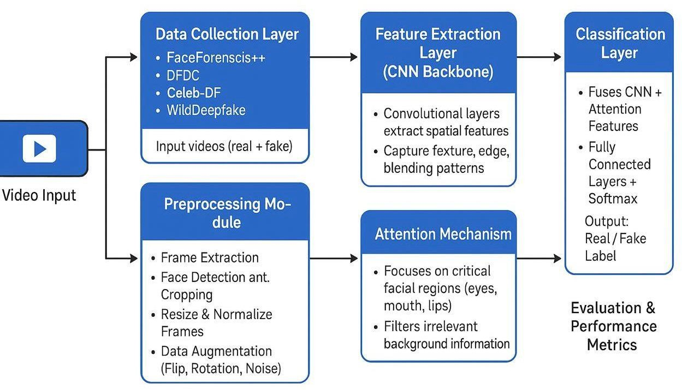
Figure 4.1: Architecture of deepfake detection The architecture shown in Figure 4.1 consists of five layers:
    - Data Collection Layer
    - Preprocessing Layer
    - Feature Extraction Layer (CNN Backbone)
    - Attention Mechanism Layer
    - Classification & Evaluation Layer

Use Case Diagram
The use-case diagram of Deepfake Detection is shown in the Figure 4.2. This consists of use cases: Upload video, Preprocessing, Feature extraction, Applying CNN models, Predicting, result.
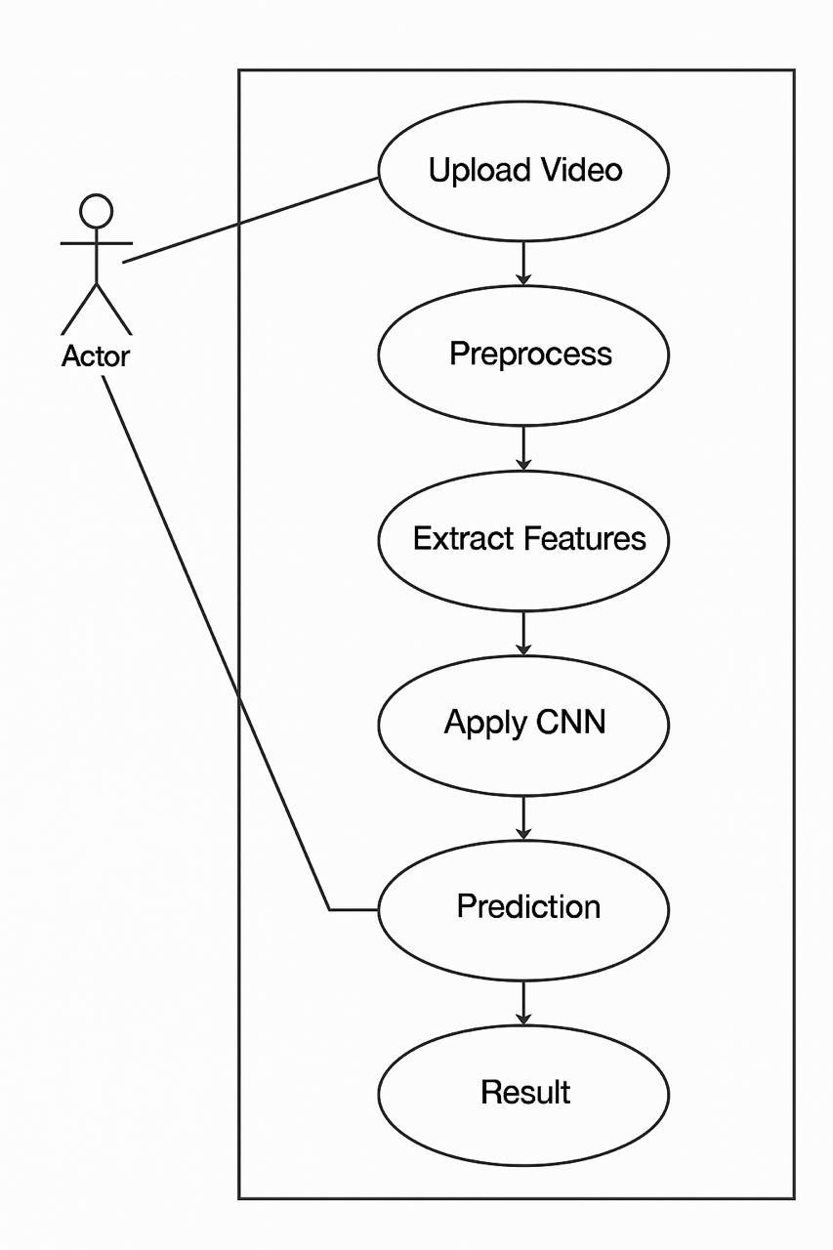

Figure 4.2: Use-case diagram of Deepfake Detection

Sequence Diagram
This sequence diagram illustrates the workflow of a Deepfake Detection System using a CNN with an attention mechanism is shown in Figure 4.3.
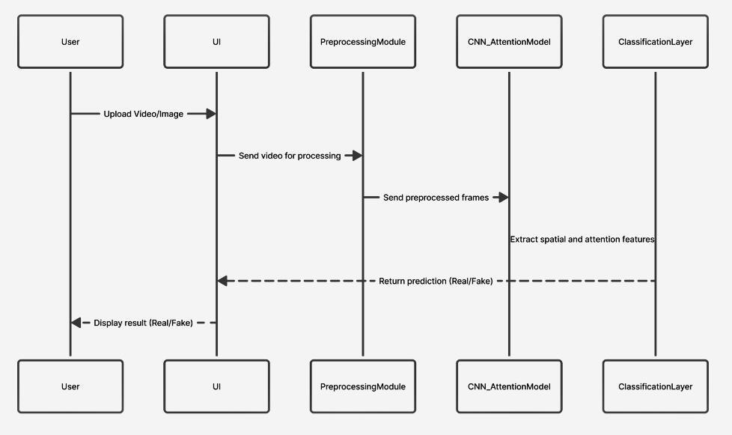

Figure 4.3: Sequence diagram of DeepfakeDetection

Algorithm / Model Description
- Preprocessing Module: The UI sends the uploaded media for preprocessing.
- Preprocessing Module CNN Attention Model: The module extracts frames and sends PreProcessed data to the CNN model.
- CNN Attention Model Classification Layer: The CNN model extracts spatial and attention-based features and forwards them for classification.
- Classification Layer UI: The classification layer returns the prediction whether the media is Real or Fake.
- The result is displayed to the user.
- The user uploads a video or image for analysis.

Tools and Technologies Used

- Programming Language:
Python is used as the primary programming language for model development and implementation.
- Frameworks and Libraries:
TensorFlow and Keras are used for building and training the deep learning model.
OpenCV is used for image and video processing.
NumPy and Pandas are used for data handling and preprocessing.
Librosa is used for audio feature extraction.
- Web Framework:
Flask is used to develop the web application and integrate the model with the user interface.
- Frontend Technologies:
HTML, CSS, and JavaScript are used to design the user interface.
- Development Environment:
Anaconda (Conda) environment is used for managing dependencies and libraries.
- Dataset Sources:
Publicly available datasets such as FaceForensics++, Celeb-DF, DFDC, and WildDeepfake are used for training and testing.

CHAPTER 5
IMPLEMENTATION

Module Structure

Data Collection
Collects real and fake images or video samples from benchmark datasets such as FaceForensics++, DFDC, Celeb-DF, and DFD to ensure a diverse and high-quality dataset for training and testing.

Data Preprocessing and Augmentation
Performs face detection, cropping, resizing, and normalization of input images.
Applies augmentation techniques like flipping, rotation, and brightness adjustment to increase data diversity and reduce overfitting.

Feature Extraction using CNN
Uses a Convolutional Neural Network (CNN) to extract spatial features such as edges, textures, and facial patterns from images that help distinguish real from fake faces.

Attention Mechanism Integration
Incorporates an attention module that focuses on key facial regions (eyes, lips, skin) and filters out irrelevant background details, improving model accuracy and interpretability.

Classification Layer (Fully Connected + Softmax)
Combines CNN and attention outputs and uses fully connected layers with a Softmax function to classify each input as Real or Fake with a probability score.

Model Training and Testing
Trains the Attention-Enhanced CNN using training data, fine-tunes hyperparameters, and evaluates it on testing data to measure accuracy and generalization performance.

Evaluation using Performance Metrics
Assesses the model’s performance using metrics such as Accuracy, Precision, Recall, F1-Score, and AUC, tested across multiple datasets to ensure robust detection.

- Integration with User Interface / Dashboard
Integrates the trained model with a simple dashboard or interface where users can upload images or videos and get real-time deepfake detection results.

  - Experimental Setup
The experimental setup of the deepfake detection system includes the datasets, hardware, software, and workflow used for model development and evaluation.
Dataset Used
The system utilizes two primary datasets for training and testing the model. The LJ Speech Dataset is used for real (genuine) audio samples, while the WaveFake Dataset is used for AI-generated (fake) audio samples. These datasets provide a diverse set of audio inputs that help the model learn to distinguish between real and synthetic content effectively.
Hardware Requirements
The system is implemented on a machine with the following minimum specifications:
- Processor: Intel i5 or higher
- RAM: 8 GB or more
- Storage: At least 10 GB of free space
- GPU: Optional (recommended for faster training and improved performance)
Software Requirements
The system is developed using the following software and tools:
- Programming Language: Python (3.x)
- Frameworks/Libraries:
  - TensorFlow/Keras – for building and training deep learning models
  - OpenCV – for image and video processing
  - Librosa – for audio processing and feature extraction (MFCC)
- Web Framework: Flask – for integrating the model into a web application
Workflow
The proposed system follows a systematic workflow to detect whether the given content is real or fake. The process begins with data collection, where datasets containing both real and AI-generated content are gathered. Real audio samples are obtained from the LJ Speech Dataset, while fake audio samples are collected from the WaveFake Dataset.
Once the data is collected, it undergoes preprocessing to make it suitable for model training. This stage includes audio cleaning, normalization, and extraction of MFCC (Mel-Frequency Cepstral Coefficients) features. If image or video data is involved, additional steps such as image resizing and video frame extraction are performed.
After preprocessing, feature extraction is carried out to identify important patterns in the data. For audio signals, MFCC features are used as they effectively capture the characteristics of sound and help distinguish between real and fake audio. These extracted features are then used as input for the model.
The next stage is model training, where a Convolutional Neural Network (CNN) is trained using the processed dataset. The model learns to differentiate between genuine and synthetic content by identifying patterns in the features. Once training is completed, the model is evaluated using performance metrics such as accuracy, precision, recall, and F1-score to ensure reliable results.
Following evaluation, the trained model is integrated into a Flask-based web application, providing an interactive interface for users. During testing, users can upload audio, image, or video files through the application. The system processes the uploaded input, extracts the necessary features, and applies the trained model to classify the content.
Finally, the prediction result is displayed to the user, indicating whether the content is real or AI-generated. The entire system is deployed locally, allowing users to access and interact with the application through a web browser.

Evaluation Metrics
The performance of the model is evaluated using the following metrics:
- Accuracy: Measures the overall correctness of the model
- Precision: Indicates how many predicted positive cases are actually correct
- Recall: Measures the ability of the model to detect all positive cases
- F1-Score: The harmonic mean of precision and recall, providing a balanced evaluation
These metrics ensure that the model provides reliable and consistent detection results.
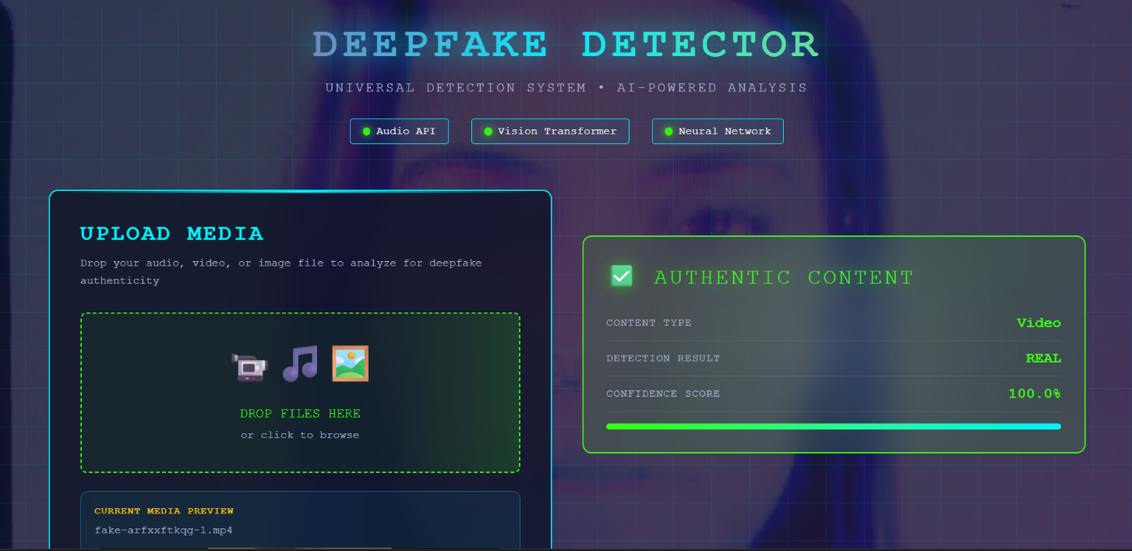
Figure 5.2.1: Screenshot of Deepfake Detection System Output



Figure 5.2.2: Output of Audio Deepfake Detection (Real)

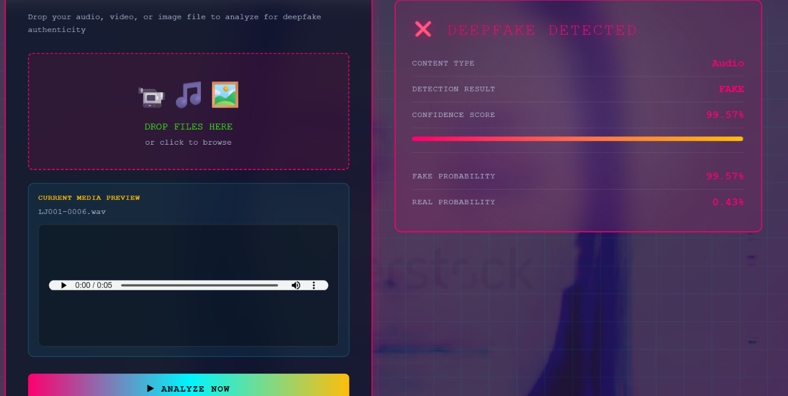

Figure 5.2.3: Output of Audio Deepfake Detection (Fake)

5.3 Dataset Description
The deepfake detection system uses multiple publicly available datasets to ensure accurate and robust performance across different types of media.
The primary datasets used include FaceForensics++, Celeb-DF, DFDC (DeepFake Detection Challenge), and WildDeepfake. These datasets contain a large number of real and manipulated videos created using various deepfake techniques, making them suitable for training and evaluating the model.
FaceForensics++ provides high-quality manipulated videos generated using different face manipulation methods. Celeb-DF focuses on realistic deepfake videos of celebrities, helping the model learn subtle inconsistencies. DFDC is a large-scale dataset released as part of a challenge, containing diverse and complex deepfake samples. Wild Deepfake includes real-world deepfake videos collected from the internet, which improves the model’s ability to generalize.
For audio detection, datasets such as LJ Speech and WaveFake are used. LJ Speech contains real human speech samples, while WaveFake consists of AI-generated audio clips, allowing the model to distinguish between natural and synthetic voices.
Overall, these datasets provide a balanced combination of real and fake samples across image, video, and audio domains, enabling the system to achieve reliable and accurate deepfake detection.
5.4 Dataset Pre processing
The dataset preprocessing step is essential to prepare raw data for effective training and testing of the deepfake detection model.
Initially, the collected datasets are organized into categories such as real and fake. For video data, frames are extracted using tools like OpenCV, converting videos into a sequence of images. From these frames, face detection techniques are applied to extract only the facial regions, which are most relevant for deepfake detection.
All extracted images are resized to a fixed dimension to maintain uniformity across the dataset. Pixel values are normalized to improve model convergence and performance during training.
For audio data, signals are processed using Librosa to extract features such as MFCC, which capture important characteristics of speech. Noise reduction and trimming techniques are also applied to remove unwanted parts of the audio.
Additionally, data cleaning is performed to remove corrupted, duplicate, or irrelevant samples. Data augmentation techniques such as rotation, flipping, and brightness adjustment are applied to increase dataset diversity and prevent overfitting.
Overall, preprocessing ensures that the data is clean, consistent, and suitable for accurate deepfake detection.

CHAPTER 6

RESULTS AND DISCUSSION

Experimental Results

The deepfake detection system was tested on various inputs, including images, videos, and audio samples, to evaluate its performance. The model successfully identified both real and fake media with a good level of accuracy.
During testing, the system was able to detect manipulated content by analyzing visual and audio inconsistencies. The results showed that the model performs well on clear and high-quality inputs, providing accurate predictions along with confidence scores.
For image and video data, the model effectively captured facial distortions and unnatural patterns. In the case of audio inputs, the system was able to recognize synthetic speech characteristics using extracted features.
The outputs were displayed through the web interface, showing whether the input is real or fake along with confidence levels. Overall, the experimental results demonstrate that the system is reliable and capable of detecting deepfake content across multiple data types.

6.2 Perfomance Analysis and Discussion

The performance of the deepfake detection system was analyzed using standard evaluation metrics such as accuracy, precision, recall, and F1-score. The model demonstrated good performance in distinguishing between real and fake media across images, videos, and audio inputs.
The system showed higher accuracy for image and video data, as visual features like facial inconsistencies and texture distortions were effectively captured by the CNN model. For audio data, the performance was slightly dependent on the quality of the input, but the model was still able to detect synthetic patterns using extracted features like MFCC.
The results indicate that the integration of an attention mechanism improved the model’s ability to focus on important regions, leading to better predictions. However, the system may show slight variations in performance when dealing with low-quality or highly compressed media.
Overall, the model provides reliable and consistent results, making it suitable for practical applications in deepfake detection. Further improvements can be made by training on larger and more diverse datasets to enhance generalization and robustness.
6.3 Comparitive Analysis

The proposed deepfake detection system is compared with existing approaches based on performance, accuracy, and capability to handle multiple data types.
Traditional methods mainly rely on handcrafted features and basic machine learning algorithms, which are less effective in detecting complex deepfake patterns. These methods often fail when the manipulations are highly realistic.
In contrast, the proposed system uses deep learning techniques, specifically a Convolutional Neural Network (CNN) combined with an attention mechanism, which enables better feature extraction and improved detection accuracy. The system is capable of identifying subtle inconsistencies in facial features and audio signals.
Unlike many existing systems that focus only on images or videos, the proposed model supports multiple input types, including audio, making it more versatile and practical for real-world applications.
Additionally, the integration of a web-based interface using Flask provides ease of use, allowing users to upload files and obtain results quickly. Overall, the proposed system outperforms traditional approaches in terms of accuracy, flexibility, and usability.

CHAPTER 7

CONCLUSION AND FUTURE SCOPE

7.1 Conclusion
The Attention-Enhanced CNN for Deepfake Detection project highlights the effectiveness of combining Convolutional Neural Networks (CNNs) with attention mechanisms to accurately detect and classify real and fake facial media. The system focuses on key facial regions such as eyes, lips, and skin textures, helping the model detect subtle manipulation cues that are often missed by traditional methods.

The Project Stage–I involved data collection from multiple benchmark datasets like FaceForensics++, DFDC, and Celeb-DF, along with preprocessing, augmentation, and initial model training. The results from this stage demonstrated high detection accuracy, improved cross-dataset generalization, and enhanced interpretability through visual attention heatmaps. These findings prove the model’s capability to work effectively across various manipulation types and compression levels.
In Project Stage–II, the focus will shift towards real-time model optimization, system integration, and deployment. The model will be integrated with a user-friendly dashboard that allows users to upload images or videos and view detection results instantly, along with highlighted attention regions for better understanding. Further, the system’s performance will be evaluated in real-world and simulated environments to ensure robustness, efficiency, and practical usability.

7.2 Sailent Features of the Work

The proposed deepfake detection system has several important features that enhance its performance and usability.
The system supports multiple input types, including images, videos, and audio, making it more versatile compared to traditional approaches that focus on a single media type. It uses a Convolutional Neural Network (CNN) combined with an attention mechanism to effectively extract and focus on important features, improving detection accuracy.
The model is capable of identifying subtle inconsistencies in facial expressions, textures, and audio patterns, enabling reliable classification of real and fake content. The integration of preprocessing techniques such as frame extraction and feature normalization ensures better model performance.
A user-friendly web interface is developed using Flask, allowing users to easily upload files and view results with confidence scores. The system also provides quick and efficient predictions, making it suitable for real-time applications.
Overall, the work offers a robust, accurate, and practical solution for deepfake detection across different types of media.

7.3 Future Scope

The deepfake detection system can be further enhanced in several ways to improve its performance and applicability.
The model can be trained on larger and more diverse datasets to improve accuracy and generalization across different types of deepfake content. Advanced deep learning architectures such as transformers can be integrated to achieve better feature learning.
Real-time detection capabilities can be improved to support live video and streaming platforms. The system can also be extended to detect deepfakes in social media content automatically.
In addition, improving audio analysis and combining multimodal learning (image, video, and audio together) can enhance detection accuracy. The user interface can be upgraded with better visualization and deployment as a mobile or cloud-based application.
Overall, the system has strong potential for further development to address evolving deepfake technologies and real-world challenges.

REFERENCES

- L. Y. Gong and X. J. Li, “A Contemporary Survey on Deepfake Detection: Datasets, Algorithms, and Challenges,” Electronics, vol. 13, no. 3, p. 585, 2024, MDPI.
- “Deepfake Detection: A Comprehensive Survey from the Reliability Perspective,” ACM Computing Surveys (CSUR), vol. 57, no. 3, 2025, ACM Digital Library.
- K. Vyas, P. Pareek, R. Jayaswal, and S. Patil, “Analysing the Landscape of Deep Fake Detection: A Survey,” International Journal of Intelligent Systems and Applications in Engineering (IJISAE), 2024.
- Heliyon, “Exploring Autonomous Methods for Deepfake Detection: A Detailed Survey on Techniques and Evaluation,” vol. 11, e42273, 2025, ScienceDirect.
- Artificial Intelligence Review, “Deepfake Video Detection: Challenges and Opportunities,” Springer, 2024.
- Discover Computing, “A Survey on Multimedia-Enabled Deepfake Detection: State-of-the- Art Tools and Techniques,” Springer, 2025.
- D. Wodajo and S. Atnafu, “Deepfake Video Detection Using Convolutional Vision Transformer,” arXiv preprint arXiv:2109.02609, 2021.
- H. Lin, W. Luo, K. Wei, and M. Liu, “Improved Xception with Dual Attention Mechanism and Feature Fusion for Face Forgery Detection,” arXiv preprint arXiv:2107.01256, 2021.
- N. Bonettini, E. D. Cannas, S. Mandelli, L. Bondi, P. Bestagini, and S. Tubaro, “Video Face Manipulation Detection Through Ensemble of CNNs,” arXiv preprint arXiv:2004.07676, 2020.
- M. A. Abdulhamed and A. N. Hashim, “A Survey on Detecting Deep Fakes Using Advanced AI-Based Approaches,” Iraqi Journal of Science, 2024.

